Bass Diffusion model to forecast products

The Bass model forecasts the adoption of innovations. At the heart of the model is the idea that there are two types of people: innovators and imitators. Innovators are those people who adopt product market innovations independently. Imitators are those people who adopt an innovation because those around them have done so. The Bass model is, therefore, a model about social networks even though it doesn’t contain any insight into the social structure per se. The model implies that something is shared between people (for example, word-of-mouth information about the product). The model doesn’t specify how the social network operates, but we understand it is there through the imitators coefficient.

The Bass model reveals coefficients for innovative consumers (p) and imitator consumers (q). We can compare those values to understand which of the two types of consumers drives the adoption of products.

Here, I will estimate simple Bass models for communication technologies – Newspapers, Radios, Televisions, Phones, Personal Computers, and Mobile Phones -- in the USA and Canada. Read below for more explanation of the Bass model, or skip to the bottom to see visualizations of the sales of these products and the Bass model forecast.

Imitators (q) and Innovators (p)

Products are adopted in the market more rapidly as other people adopt them. Underneath this adoption process is the idea that there are social aspects that can encourage people to adopt a product. For example, being the first to adopt a mobile phone gains limited advantages. As a business person, one may be able to make more sales with a mobile phone. This was how I felt in the early days of having a BlackBerry. It was fun, but in those early days, you could only email or talk with other BlackBerry users on the go.

However, as a product becomes more widely adopted, others imitate and adopt the mobile phone primarily because they know it is expected that they can be in constant contact with their friends and co-workers. Today, having a mobile phone is expected. During the COVID pandemic, many governments required travelers to have forms filled out on national apps.

Bass Model

The Bass model formalizes these ideas. In its simplest form, the Bass model is a regression of each period’s product sales against cumulative sales to that point and cumulative sales squared. This gives a simple model explaining each period's sales based on previous sales.

The core intuition is that the likelihood L(t) of consumer adoption at period t is equal to the likelihood of adoption in a given period f(t) divided by one minus the cumulative probability of adoption F(t).

$$L\left(t\right)=f\left(t\right) / 1–F\left(t\right)$$

In 1969, Bass proposed that the likelihood was equal to:
$$L(t) = p + \frac{q}{N}(t)$$
In other words, the likelihood equals the coefficient of innovators (or external influence) (p) plus the imitators (internal influence) (q) normalized by the total number of customers who already adopted the product.

In practice, if we have enough data, we can estimate p and q from the simple regression equation of sales against cumulative sales (mentioned above). In the process, we also estimate the market size for the product (m). In practice, however, the regression model can suffer from omitted variable bias without some more controls, or it may simply not have enough observations to provide us with certainty in the results. These factors can result in a negative p or q in the calculations. In this case, I will not show the forecast.

Data and Methods
The data is from the Historical Cross Country Technology Adoption Dataset collected by Comin and Hobijn. The dataset contains the development of technologies across the world. For simplicity, I focus on communication technologies in the USA and Canada to analyze using the Bass forecasting model.
The regression uses the Python statsmodels package. I also used the bassmodlediffusion package as a starting point for some calculations. I reworked the visualizations, data handling, and some of the calculations. The output of visualizations is automated and can be done for any product or country in the technology adoption dataset.
Overall Results – The Rise of Network Effects on Product Sales

Technology | Country | Est total sales | p | q
Mobile Phones | United States | 1,265,244 | 0.0006 | 0.3285
Mobile Phones | Canada | 154,895 | 0.0007 | 0.2856
Personal computers | Canada | 277,163 | 0.0014 | 0.1949
Personal computers | United States | 5,738,844 | 0.0022 | 0.141
Radios | Canada | 1,113,882 | 0.0019 | 0.0863
Radios | United States | 24,282,855 | 0.0022 | 0.0756
Televisions | United States | 14,956,151 | 0.0015 | 0.0609
Phones | Canada | 1,553,861 | 0.0001 | 0.0597
Phones | United States | 18,395,233 | 0.0001 | 0.051
Televisions | Canada | 19,321,949 | 0.0002 | 0.0449
Newspapers | United States | 6,037,532 | 0.0084 | 0.0213
Newspapers | Canada | -315,825 | -0.0103 | 0.0033

The overall results table allows us to compare the relative sizes of the coefficients for consumer innovation (p) and imitation (q) between the different countries and products. (The bolded products had the values on the y-axis of their visualization scaled by 1000 for easier reading.)

The products with the largest consumer innovation coefficient are US Newspapers. (We ignore the Canadian data in this case for reasons explained below.) The imitation coefficient is consistently larger for each case. The values for innovation (q) are largest for mobile phones and personal computers, followed by other communication methods.

One explanation is that mobile phones and personal computers have strong network effects – these technologies become more valuable the more others choose to adopt them. We don’t see the same imitation effects in other mass media innovations like radio, television, or telephones. In the latter case, the high cost of installing land-line telephones and the inconvenience of use at a fixed location may be significant reasons why imitation effects were not as strong for this technology.

Newspapers

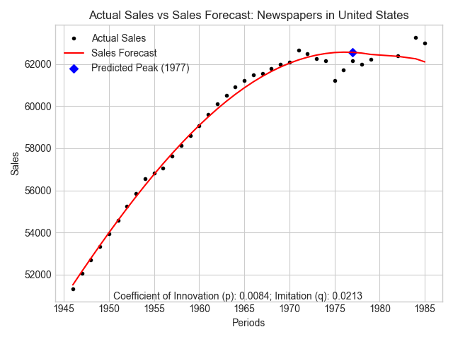
The first visualization shows the adoption of Newspapers in the USA from the post-war period. The simple Bass model does a good job of tracking the diffusion rate of newspaper sales over time. The imitation coefficient, q, is much larger than the innovation, p, coefficient. Because q > p, the graph takes on an inverted U shape. Newspaper sales for this dataset were forecast to peak in 1977. It can be seen that this estimate is not too far from the data.

The Canadian example is excluded because the value of p was estimated to be below zero. This indicates that the model did not do a good enough job of estimating the series. The visualization confirms that the data is much more complex than the US case. Likely, the addition of other explanatory variables would improve the estimates.

Radio
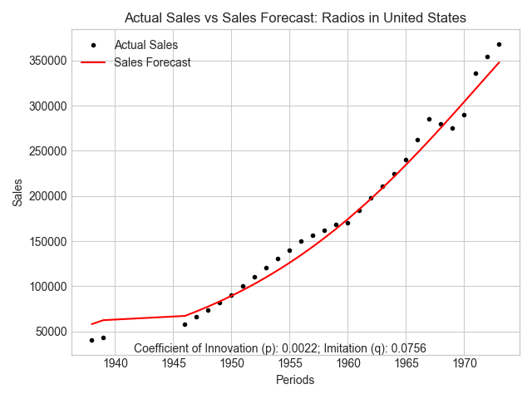 | 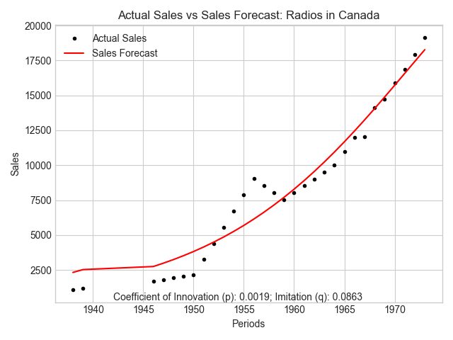

Radio sales forecasts also show a close fit to the data from the early 1980s. Some exceptions, such as the post-1950 adoption in Canada, are not accounted for. This indicates that the model could likely be improved by adding further explanatory variables.

Phones
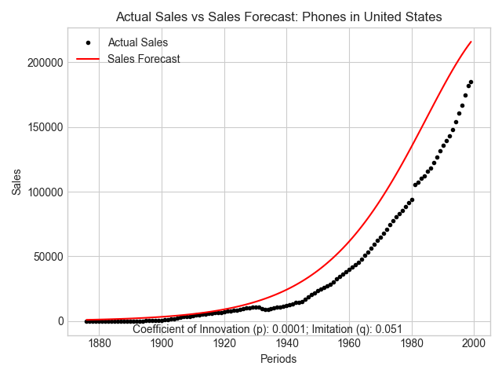 | 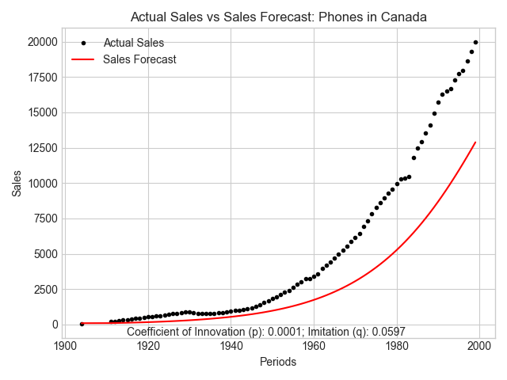

The simple Bass model reasonably estimates the US and Canadian data, but there is clear room for improvement. Gaps in adoption post World War I and increases post-World War II are noticeable features that the simple forecast model misses.

Televisions
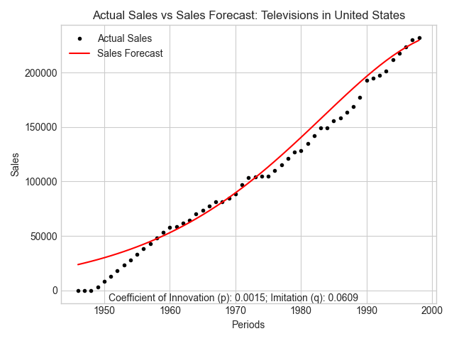 | 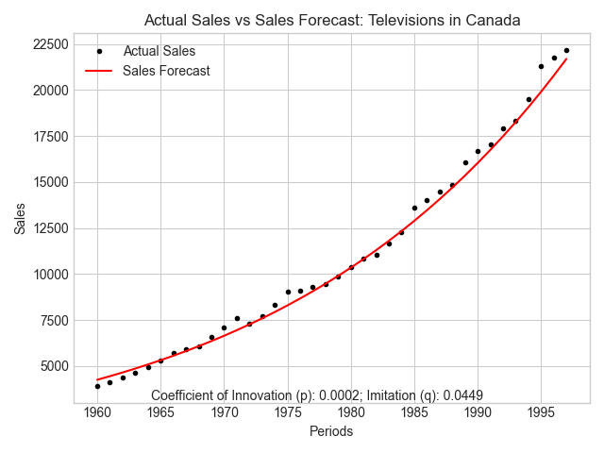

The forecasts of television adoption are very close. In both cases, up to the end of the data in 2000, there is no indication of a slow in demand.

Personal Computers
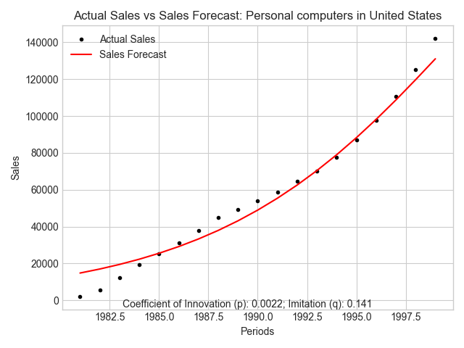 | 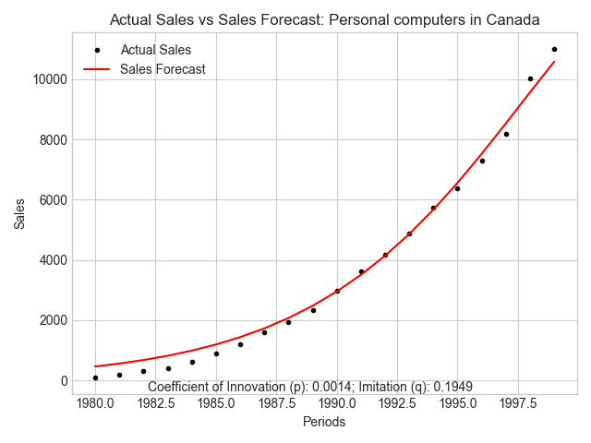

The sales of personal computer sales in the USA and Canada show no sign of reaching a peak in the data. Likely, we would see a decline in this product that coincides with the increase in the adoption of laptops and other personal digital assistants.

Mobile Phones
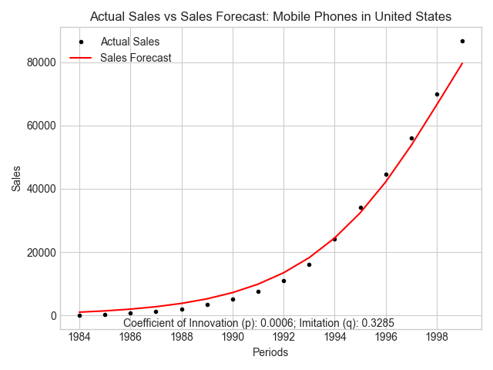 | 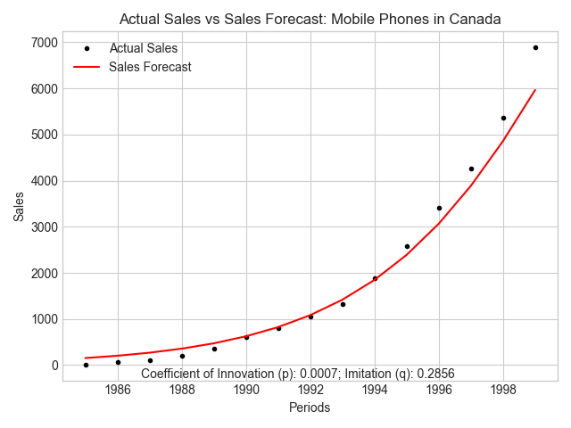

We see a similar increase in sales of mobile phones into the early 2000s. A closer examination of this market, including the significant competitors, would be interesting given the early rise and sharp decline of BackBerry, the popularity of Android, and the introduction of the iPhone. (To say nothing about the sharp decline of Nokia and Ericsson phones during this later period.)

Summary

The Bass forecasting model helps forecast consumer sales and compare how different types of products can be marketed to consumers. This brief paper examined data from sales of communication products ranging from personal communication to mass media devices. We can see that more modern products like personal computers and mobile phones have strong network effects that encourage consumers to purchase as more of their peers adopt them.

